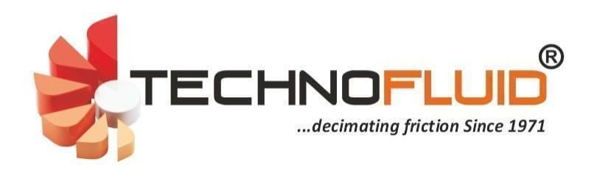
PRODUCT DATA SHEET

REAR AXLE OIL (JCB & OFF-HIGHWAY EQUIPMENT)
Commercial / Pack Name: Rear Axle Oil (JCB) SAE 80W / SAE 90
Product Description
- Premium rear axle oil formulated with high quality mineral base oils and advanced extreme pressure (EP) additives.
- Designed for rear axles, differentials and final drives used in JCB construction equipment and off-highway machinery.
- Provides outstanding protection under heavy shock loads and severe operating conditions.
- Excellent oxidation stability, rust and corrosion protection for extended service life.
- Suitable for equipment operating in construction, mining and earthmoving applications.
Key Performance Benefits
- Excellent extreme pressure and anti-wear performance.
- High load carrying capability for heavily loaded gears.
- Reduces gear scuffing, pitting and wear.
- Excellent thermal and oxidation stability.
- Protects against rust, corrosion and foam formation.
Applications
- JCB backhoe loaders and construction equipment.
- Rear axle assemblies and final drives.
- Differentials of earthmoving and off-highway equipment.
- Suitable where EP gear lubricants meeting API GL-5 or equipment manufacturer recommendations are specified.
INDUSTRY PERFORMANCE CHARACTERISTICS
- Outstanding EP protection
- Excellent load carrying capability
- Superior wear protection
- Excellent oxidation stability
- Extended component life
Typical Characteristics
Characteristics | SAE 80W | SAE 90
Appearance | Bright & Clear | Bright & Clear
Density @29.5°C | 0.890 | 0.895
K.V @40°C cSt | 75 | 180
Viscosity Index | 105 | 95
Flash Point (COC) °C | 210 | 220
Pour Point °C | -27 | -12

